NETFLIX CONTENT STRATEGY
ANALYSIS

ABOUT NETFLIX

- Netflix is an online streaming platform where users can watch movies, TV shows, web series, and documentaries through the internet.

- It was founded in 1997 by Reed Hastings and Marc Randolph. The company is located in Los Gatos, California, United States.

- In the beginning, Netflix worked as a DVD rental service. Later, it changed into a digital streaming platform where users can watch content online.

- Today, Netflix is available in many countries and has millions of users around the world. It also produces its own shows and movies called Netflix Originals.

- Some popular Netflix Originals include Stranger Things, Money Heist, and Squid Game.

- Users need to pay a monthly subscription to use Netflix. The platform can be accessed on smartphones, laptops, tablets, and smart TVs.

- Netflix is now one of the most popular streaming services in the world.


PROBLEM STATEMENT

- Netflix operates in a very competitive streaming industry.

- It competes with platforms like Amazon Prime Video and Disney+.

- One major challenge for Netflix is attracting new users and keeping existing subscribers.

- Netflix must continuously update its content.

- Producing high-quality movies and TV shows is expensive and requires large investments.

- Another issue is password sharing, which reduces the number of paid subscriptions.

- Subscription cancellations can also affect the company’s revenue.

- Netflix must also create more regional content because viewers from different countries prefer content in their local language.

- To stay successful, Netflix must keep improving its content, technology, and recommendation system.


DATASET OVERVIEW

- The Netflix dataset contains information about movies and TV shows available on the Netflix platform.

- It helps us understand how content is distributed across different genres, countries, and years.

- Each row in the dataset represents one movie or TV show.

- This dataset is useful for performing data cleaning, exploratory data analysis (EDA), and visualization.

- Using this dataset, we can analyse:

    - Number of Movies and TV Shows
    - Content growth over the years
    - Most common ratings
    - Popular genres
    - Country-wise content production

- This analysis helps understand trends in Netflix content.

DATA PREPARATION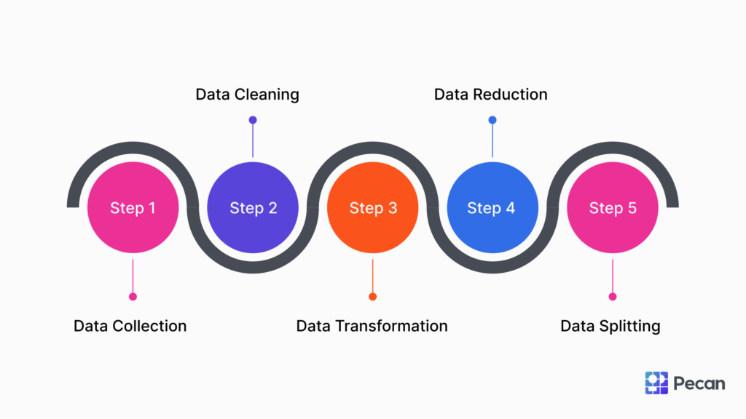

Introduction
Data preparation is an important step before analysing data. In this project, the Netflix dataset was cleaned and prepared to make the analysis accurate.
Total Number of Titles
- To find the total number of titles available on Netflix, the Show ID column was used.
- In Tableau the following function was applied:
COUNT (Show ID)
This counts all movies and TV shows in the dataset.
Movies v/s TV Shows
- To see how many movies and TV shows are available, the Type column was used.
- Using COUNT (Show ID), we can compare the number of movies and TV shows.
- Year and Month Added
- The Date Added column was converted into date format.
- Two calculated fields were created:
Year Added:
YEAR ([Date Added])
Month Added:
DATENAME ('month', [Date Added])
This helps analyse when content was added to Netflix.
Separating Duration
- The Duration column contains minutes for movies and seasons for TV shows.
- Two calculated fields were created to separate them.
Movie Duration
IF [Type] = "Movie" THEN
INT (REPLACE ([Duration], "min", ""))
END
TV Show Duration
IF [Type] = "TV Show" THEN
INT (REPLACE (REPLACE ([Duration], "Seasons", ""), "Season", ""))
END
This allows us to analyse movie length and number of TV show seasons.
Finding Unique Values
To count unique values in some columns, the following functions were used:
COUNTD ([Country])
COUNTD ([Listed In])
COUNTD ([Cast])
COUNTD ([Director])

This helps understand diversity in countries, genres, actors, and directors.
Columns that Need Splitting

Some columns contain multiple values separated by commas.
These include:
- Country
- Genre (Listed In)
- Cast
- Director
- These columns were split to make analysis easier.



1.ANALYSING BASIC METRICS

Basic metrics are numerical measures used to summarize, understand, and analyse data.
Import libraries:
Open Jupiter Notebook or google colab
Import raw data:
Open Jupiter Notebook or colab notebook
On the home page, click Upload (top-right)
Select your .csv file 0r excel file
Click Upload again (next to the file name)

Understanding dataset:
Shape of Dataset
Shows total number of rows (restaurants) and columns (features)
Info of dataset
To display a summary of a DataFrame, including its structure and data types.
Head of Dataset
Displays first 5 records to understand data structure
Tail of Dataset
Displays last 5 records to check data consistency
Column Names
List of all features present in the dataset
missing value detection
Missing values detection is the process of identifying empty, null, or undefined values in a dataset before handling or replacing them.
Fill NA
Used to replace missing values (Nan, None) In a dataset
Describe
Summary statistics like count, mean, min, max for numerical columns
Conversion of categorial columns to category
Categorical data conversion is the process of transforming text or label-based data into numerical form so that it can be used for analysis
Non-graphical analysis
Value counts: Value counts refer to the number of times each unique value appears in a dataset or in a specific variable/column.
value counts of(release year)
Unique values:
Unique values are the distinct, non-repeated values present in a dataset or in a specific variable/column.
Univariate analysis:
Univariate analysis is a type of data analysis that focuses on examining a single variable at a time to understand its characteristics, distribution, and patterns.

DISPLOT
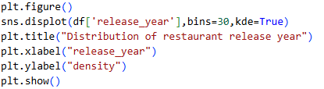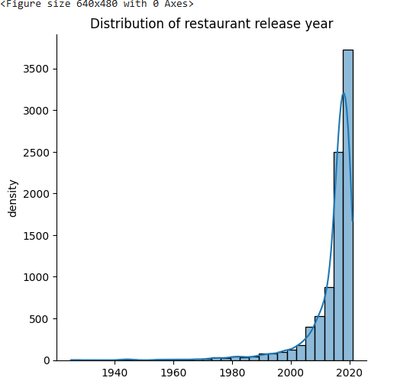
COUNTPLOT
Plt.figure ()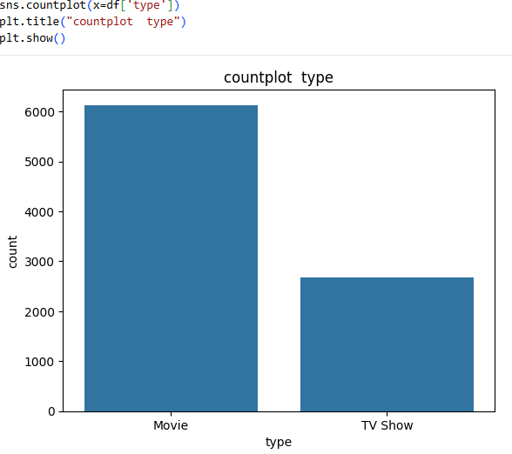

HISTOGRAM PLOT
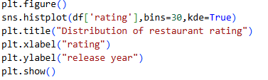
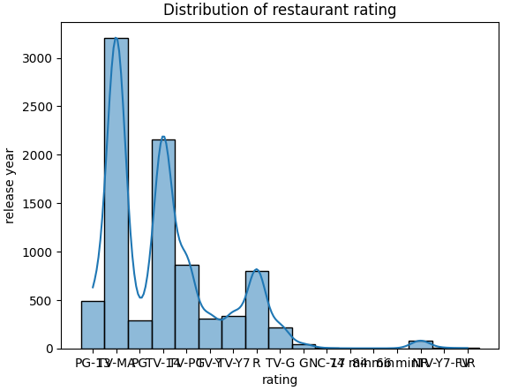
BIVARIENT ANALYSIS
- Bivarient analysis studies the relationship between two variables.
- It helps identify patterns, correlations, and differences.
- Common methods include scatter plots, correlation, regression, and box plots.

BOXPLOT
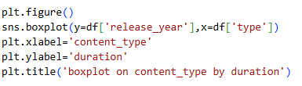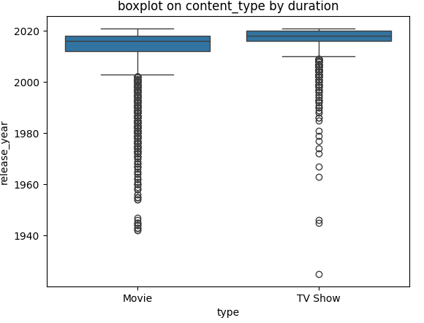

Heat map
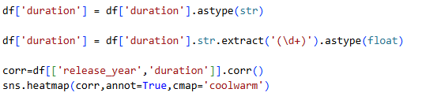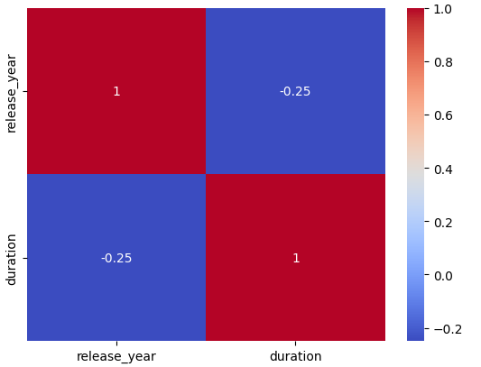

PAIRPLOT
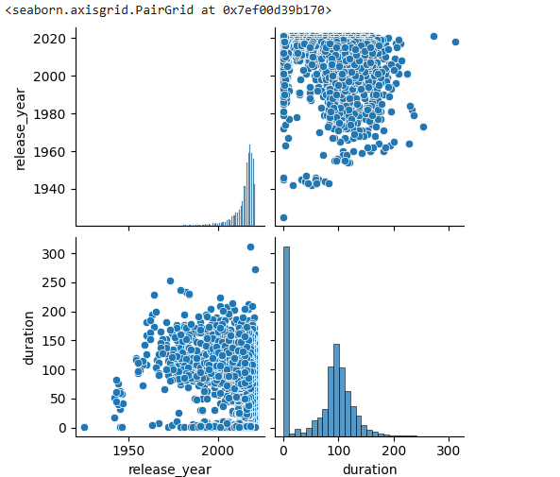
Missing value:
Missing values are data entries where no value is recorded for a particular variable or observation.
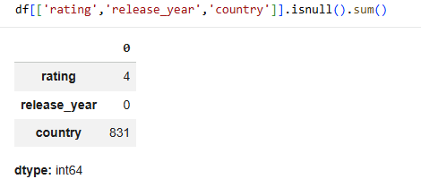
Outiler detection:
Outlier detection is the process of identifying data points that significantly differ from the rest of the data.
Type:
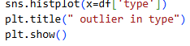
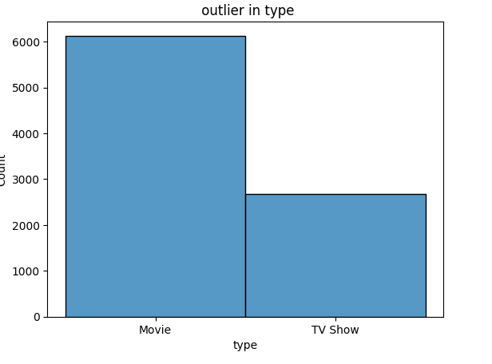

Duration:
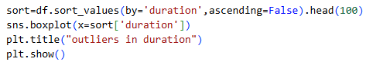
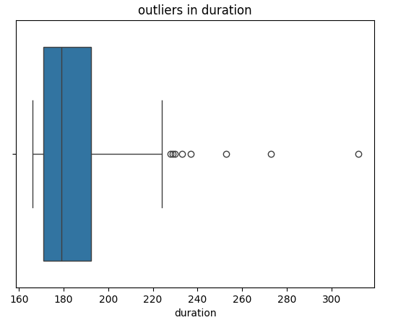

DASHBOARDS


Dashboard 1
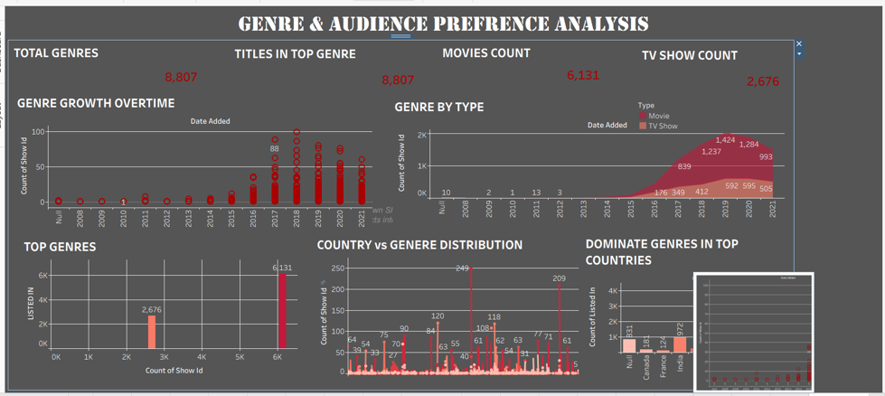

Insights
• The dataset contains 8,807 total titles, showing a large and diverse content library.
• Movies dominate the platform with 6,131 titles, while TV Shows account for 2,676 titles.
• Content growth increased significantly after 2016, indicating strong expansion of the platform.
• The highest content addition occurred between2018 – 2020, suggesting Netflix invested heavily in new content during this period.
• Movies are consistently more numerous than TV Shows across most years.
• Some countries contribute significantly more titles than others, showing unequal global content distribution.
• A few genres dominate the platform, meaning audience preference is concentrated in popular genres.
• The Top Genres contain the largest portion of total titles, indicating viewer demand is focused on specific categories.

Recommendations
• Netflix should increase production of TV Shows, as long-form content improves viewer retention.
• Invest more in high-performing genres since they attract the largest audience.
• Expand content production in underrepresented countries to improve global reach.
• Continue the content growth strategy introduced after 2016, which significantly increased platform content.
• Analyse audience behaviour for top genres to create personalized recommendations.
• Maintain a balanced mix of movies and series to satisfy different viewer preferences.
• Introduce more regional and cultural genres to attract new international audiences.

Dashboard 2

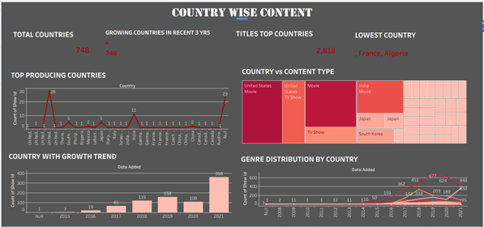

Insights
- Total 748 countries are producing content on the platform.
- United States is the top producing country with the highest number of titles.
- India and UK are also major contributors to content production.
- Most other countries contribute very few titles (1–5).
- Top countries together produced around 2,818 titles.
- France and Algeria have the lowest content production.
- Movies are more common than TV Shows across most countries.
- Countries like Japan and South Korea mainly produce movie content.
- Content growth increased significantly after 2017.
- 2021 shows the highest number of titles added (358).
- Content production peaked around 2019 in genre distribution.

Recommendations
- Increase content production in low-performing countries.
- Invest more in TV Show production to balance content types.
- Focus on growing markets like India, Japan, and South Korea.
- Encourage regional and international collaborations.
- Improve genre diversity to attract different audiences.
- Continue the content expansion strategy after 2017.

Dashboard 3

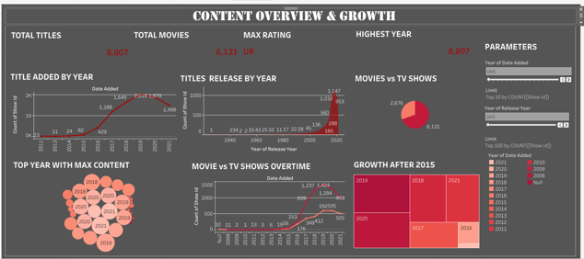
Insights
- Total Titles: 8,807 shows available on the platform.
- Movies dominate content: 6,131 movies compared to fewer TV shows.
- Content growth increased rapidly after 2016.
- 2019 has the highest number of titles added to the platform.
- Content addition peaked between2018–2020, showing aggressive expansion.
- Earlier years (before 2015) had very limited content additions.
- Recent years show slight decline in new titles added after the peak.
- Most releases are concentrated in recent decades (2000–2020).
- Movie additions increased faster than TV shows over time.
- 2018–2020 is the strongest content growth period in the dataset.
Recommendations
- Increase TV show production, since movies already dominate the platform.
- Focus on recent release years (2015–2021) because audience demand is higher for newer content.
- Maintain the high content acquisition strategy used in 2018–2019 to sustain platform growth.
- Invest in original content to maintain competitive advantage.
- Balance movies and TV shows to attract different viewer preferences.
- Analyse the decline after 2020 to understand possible production or acquisition issues.
- Target trending genres and regions to increase viewer engagement.
- Use data-driven decisions to plan future content acquisition and release strategy.

